

**Course:**

“Object Oriented Programming with Java”

**Course Instructor:**

Ma’am Shaista Malik

**Submitted by:**

Muhammad Bilal Athar

**Roll no:**

2k24-BSCS-401 (Section Y)

**Quiz of Method Overloading**

**Task1: Create a Calculator Class**

* Create a Java class named **Calculator** that has multiple overloaded methods named add().
* The **add()** method should support:

1. Adding two integers
2. Adding two double values
3. Adding three integers
4. Concatenating two strings

**Source Code:**

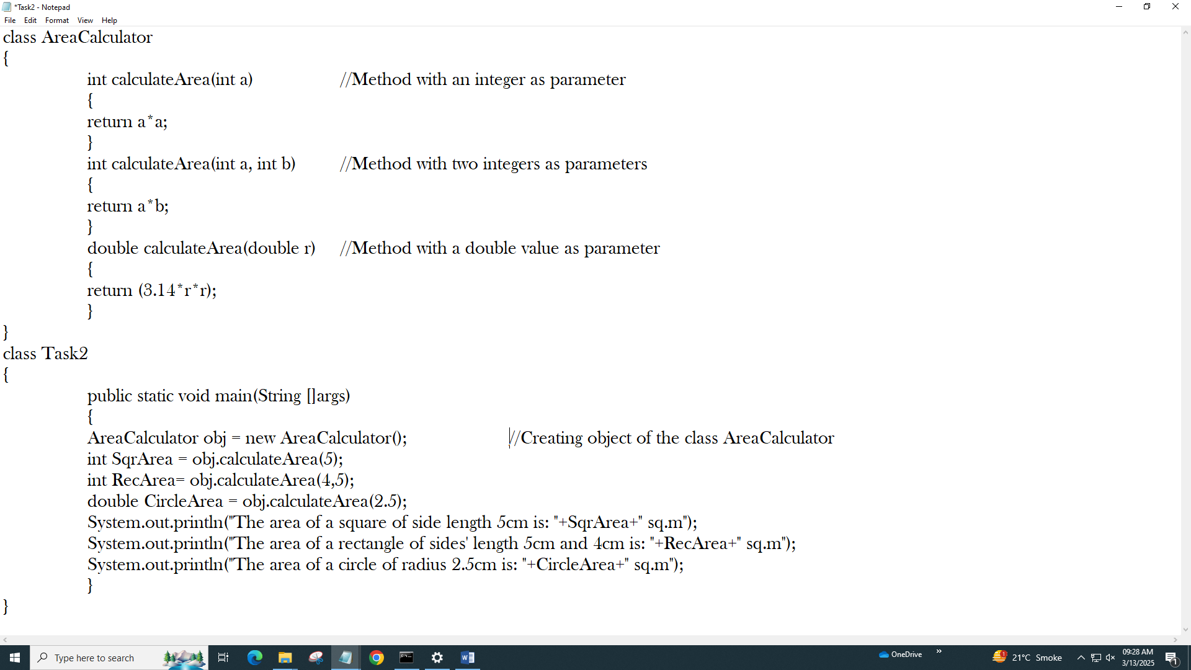

**Output:**

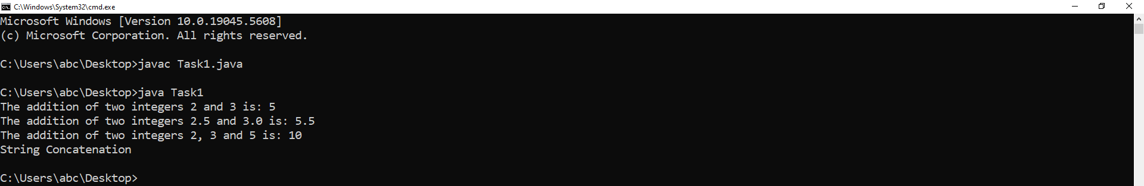

**Task2: Method Overloading with Different Parameter Orders**

* Create another Java class named **AreaCalculator**.
* Implement overloaded methods **calculateArea()** to calculate:

1. Area of a square (one integer parameter for side length)
2. Area of a rectangle (two integer parameters for length and width)
3. Area of a circle (one double parameter for radius)

**Source code:**



**Output:**

